MIT App Inventor 2 – Components
User Interface | Layout |  | Media | Drawing and Animation
Button  CheckBox  Clock  DatePicker  Image  Label  ListPicker  ListView  Notifier  PasswordTextBox  Slider  Spinner  Switch  TextBox  TimePicker  WebViewer | HorizontalArrangement  HorizontalScrollArrangement  TableArrangement  VerticalArrangement  VerticalScrollArrangement |  | Camcorder  Camera  ImagePicker  Player  Sound  SoundRecorder  SpeechRecognizer  TextToSpeech  VideoPlayer  YandexTranslate | Ball  Canvas  ImageSprite
Maps | Sensors | Social |  | Storage
Circle  FeatureCollection  LineString  Map  Marker  Polygon  Rectangle | AccelerometerSensor  BarcodeScanner  Clock  GyroscopeSensor  LocationSensor  NearField  OrientationSensor  Pedometer  ProximitySensor | ContactPicker  EmailPicker  PhoneCall  PhoneNumberPicker  Sharing  Texting  Twitter |  | File  FusionTablesControl  TinyDB  TinyWebDB
Connectivity | LEGO® MINDSTORMS® |  |  | Experimental
ActivityStarter  BluetoothClient  BluetoothServer  Web | NxtDrive  NxtColorSensor  NxtLightSensor  NxtSoundSensor  NxtTouchSensor  NxtUltrasonicSensor  NxtDirectCommands | Ev3Motors  Ev3ColorSensor  Ev3GyroSensor  Ev3TouchSensor  Ev3UltrasonicSensor  Ev3Sound  Ev3UI  Ev3Commands |  | CloudDB  FirebaseDB

MIT App Inventor 2 – Language Structures 1
Control
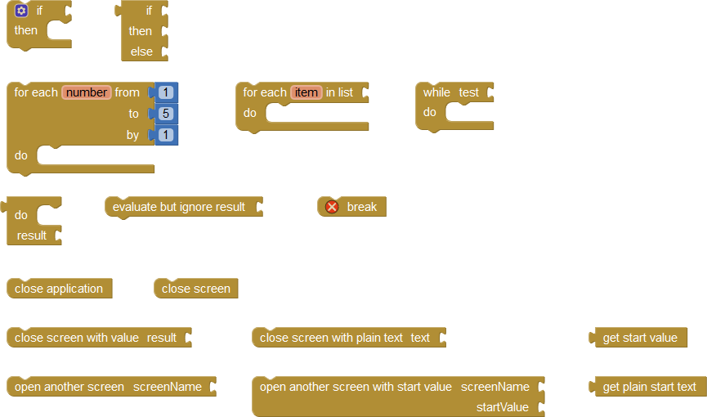
Variables
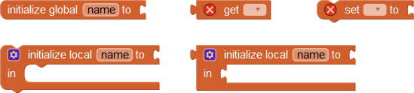
Procedures
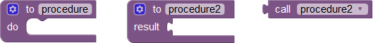
Colors
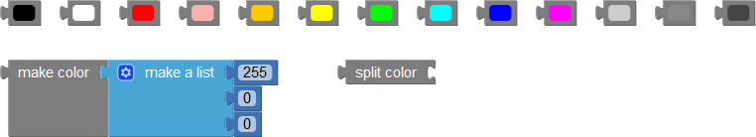
Logic

MIT App Inventor 2 – Language Structures 2
Math
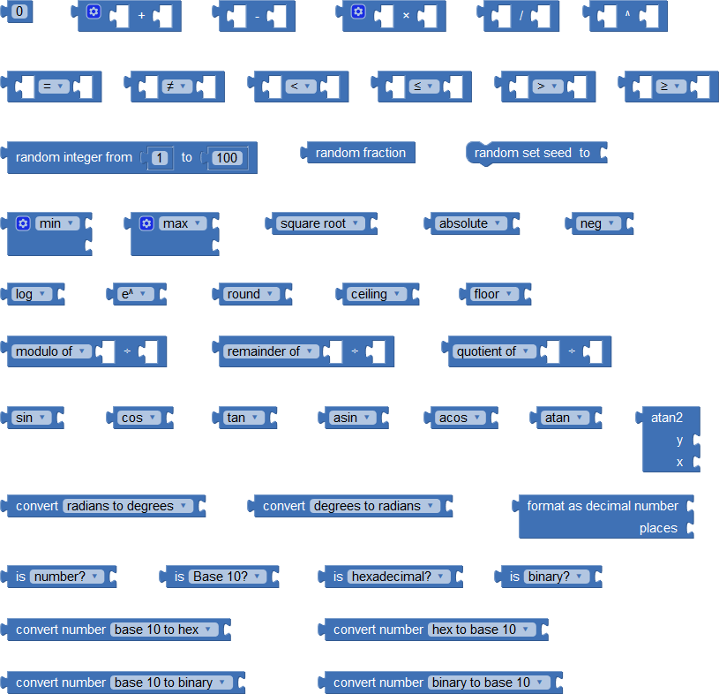
Text
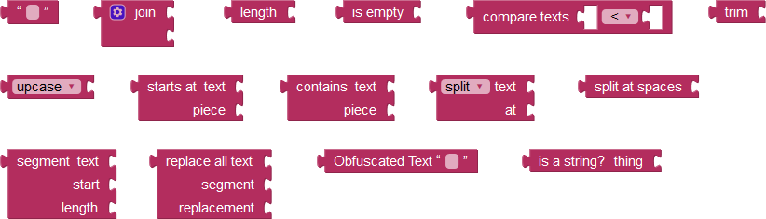

MIT App Inventor 2 – Language Structures 3
Lists
